Making a Difference in Your OWN Way!
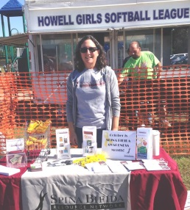
Thank you for taking your time and energy to help raise funds for SBRN. With your help, we will continue our unique personalized services to people with spina bifida and other disabilities.

Howell Girls Softball League & NJ
Heat Fastpitch
organization run a
large Softball
Tournament that
Benefits SBRN!

Families have sold Spina Bifida
Awareness bracelets
and yellow ribbon
pins to benefit SBRN.

Liz M. ran a bake sale
and donated the
proceeds to SBRN.

Asking for money does not have to be awkward or difficult! Below are some ways to promote a pledge page for the walk for peer-to-peer fundraising, and then we illustrate some examples of other ways to fundraise. As always, we are very willing to help with support for any endeavor you would like to initiate—just call us! 908-782-7475 or email info@thesbrn.org.
How to Create a Successful Pledge Page!
- Start a Pledge Page – Whether you are a roller/walker or a virtual participant (if you can’t attend, but would still like to raise money for the cause), begin by creating a personal pledge page at www.thesbrn.org.

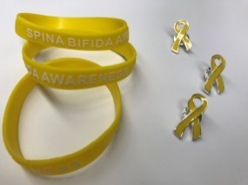
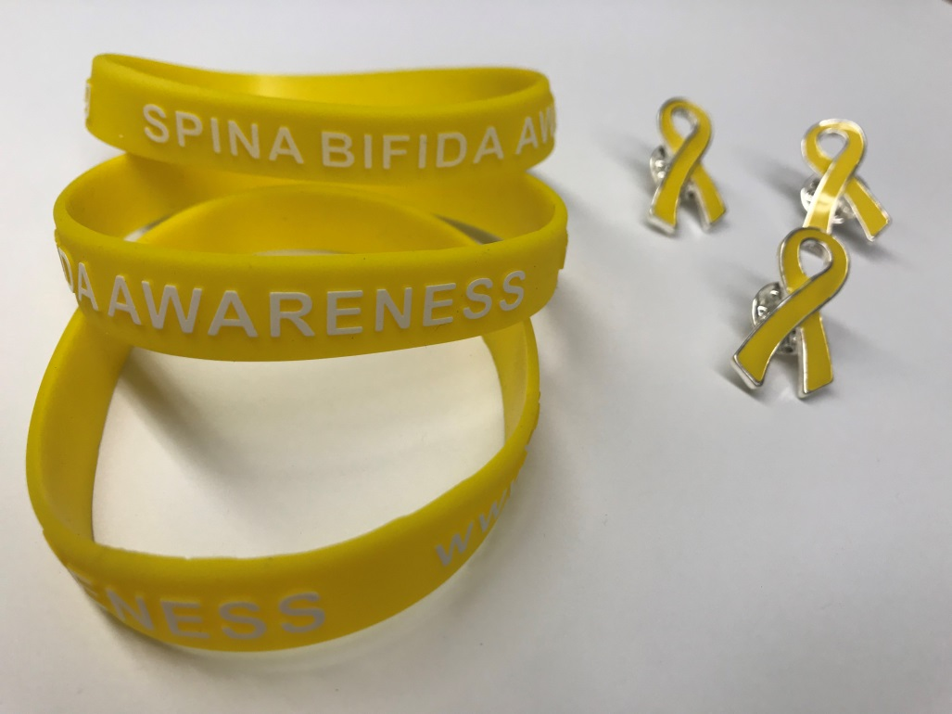
- Get personal - YOU are our best advocate when communicating to your friends and supporters, and YOUR STORY is what they want to hear! If you have been touched by SB, or have received a helpful service from SBRN, then share your story! Include a picture to make it even more personal.

- What are they supporting? - People like to know exactly how their donations will help. The answer is simple. Funding will continue to send nurses and family support coordinators to people’s homes, schools, medical visits, and hospital beds. The services SBRN provides to children, adults and families help empower them to thrive in their environment.
- Get EXCITED! - People love positivity and enthusiasm, so spread the joy of what you are doing and why it means so much to you! You can also invite them to join you at the Walk!

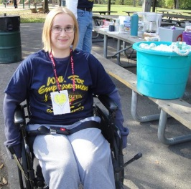
- Share it on Social Media – Post it on Facebook, Twitter, Instagram, Snapchat and be sure to use: #spinabifida and #walkforempowerment.
- Get them started – Often people don’t like to go first. Make a small donation or ask a friend to get it started and then others will join in!
- SAY THANK YOU!! - SBRN sends acknowledgments to all donors on file, however, nothing would mean more to your supporters than a personal note of gratitude from you. We can help with this, as well.
Different Ways to Raise Funds
(and Spina Bifida Awareness, too!)

Millie G. coordinated a fun night out at a restaurant to benefit SBRN.

Steph Lisa organized a fun night of Line Dancing in Rockaway to raise awareness and Funds!

A Girl Scout Troop from Flemington collected books for the ongoing Book Drive Fundraiser for SBRN.

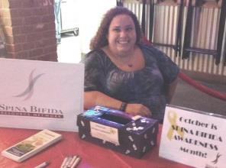
You can support us in a variety of ways at your own comfort level. There are many fun ways to raise funds, and we would love to help you with any of these exciting endeavors!
- Throw a Party—Go nuts with a theme (movies, costume, karaoke, murder mystery, 80’s, celebrity look-a-likes, board games, poker, etc. --the sky is the limit!) Ask attendees to bring a donation of their choosing sealed in an envelope for privacy, along with their dish or pot luck. You could start a fun tradition, here!
- Garage or Yard Sales—Clear out clutter for a cause! Post signs to raise awareness of spina bifida and say who the proceeds are going to.
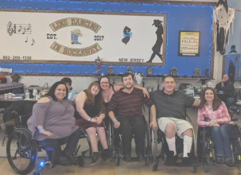
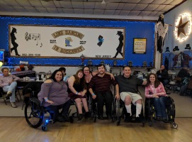
- Change Counts! Throw your change in a jar for a month. You’ll be surprised how much it adds up to! Or better yet, ask 10 people to save their change for a month—make a night of counting!

- Sell Spina Bifida Awareness bracelets or Yellow Ribbon pins – Contact us and we can provide you with pins or bracelets.

- Hold a bake sale – Everyone loves cookies and brownies. Maybe a club at your school would be interested in helping!
- Seek employer support! Some companies offer to either match gifts for their employees’ causes or sponsor events.
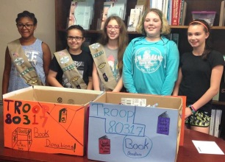
- Raise awareness and funds at a Restaurant Dine-In Fundraiser – Many restaurants (especially chains) will donate a percentage of the proceeds from diners with coupons for a specific night. Invite your friends to eat at the restaurant that night and have a fun night out!

- Host a Themed Event at your favorite restaurant, bar or other venue. You can be creative – karaoke, dancing, self-defense, sports, etc. If you know of a location that would be open to hosting an event for you, we’d be happy to roll up our sleeves and help!

Get your creative juices flowing, engage your friends, family and co-workers, and let’s see what we can do together!

